Name : SHIKHA Mail id : 22053885@kiit.ac.in
Superset id : 6364496 University Roll : 22053885

WEEK - 08 : HandsOn Solutions

#1. Git - 01

KIIT@BT-22053885 MINGW64 ~
$ git version
git version 2.46.2.windows.1

KIIT@BT-22053885 MINGW64 ~
$ git config --global --list
user.gmail=saswatnyk123@gmail.com
user.name=Saswata Kumar Nayak
user.email=saswatnyk123@gmail.com

KIIT@BT-22053885 MINGW64 ~
$ notepad++

KIIT@BT-22053885 MINGW64 ~
$ notepad++.exe bash -profile

KIIT@BT-22053885 MINGW64 ~
$ git config --global core.editor "notepad++.exe -multiInst -nosession"

KIIT@BT-22053885 MINGW64 ~
$ git config --global -e

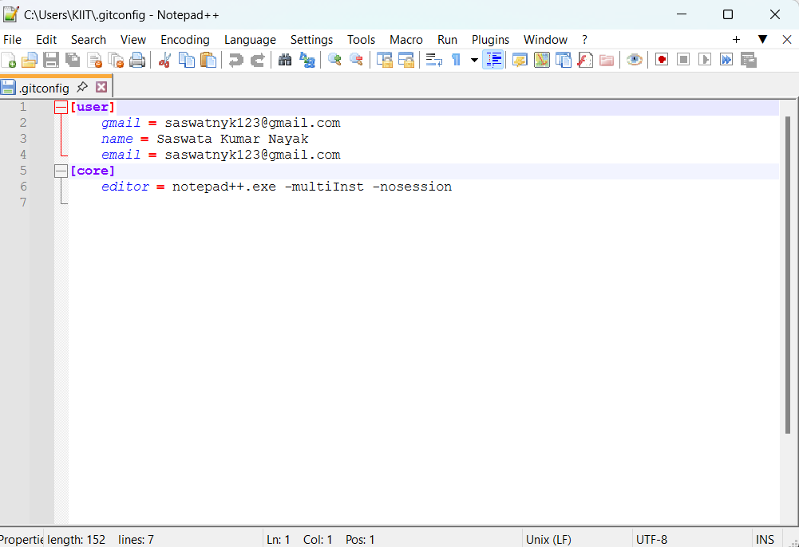
KIIT@BT-22053885 MINGW64 ~
$ git init GitDemo
Initialized empty Git repository in C:/Users/KIIT/GitDemo/.git/

KIIT@BT-22053885 MINGW64 ~
$ ls -al
total 27429
drwxr-xr-x 1 KIIT 197121 0 Aug 9 12:36 ./
drwxr-xr-x 1 KIIT 197121 0 Oct 25 2022 ../
drwxr-xr-x 1 KIIT 197121 0 Jul 10 2023 .MobiVBox/
-rw-r--r-- 1 KIIT 197121 175 May 25 14:31 .angular-config.json
-rw-r--r-- 1 KIIT 197121 174 Aug 9 12:21 .bash_history
drwxr-xr-x 1 KIIT 197121 0 Dec 27 2023 .cache/
drwxr-xr-x 1 KIIT 197121 0 Feb 26 2023 .dbus-keyrings/
drwxr-xr-x 1 KIIT 197121 0 Jun 19 19:53 .dotnet/
drwxr-xr-x 1 KIIT 197121 0 May 6 14:51 .eclipse/
-rw-r--r-- 1 KIIT 197121 152 Aug 9 12:34 .gitconfig
drwxr-xr-x 1 KIIT 197121 0 May 24 01:32 .gradle/
-rw-r--r-- 1 KIIT 197121 20 Aug 9 12:26 .lesshst
drwxr-xr-x 1 KIIT 197121 0 May 25 13:17 .m2/
drwxr-xr-x 1 KIIT 197121 0 Feb 5 2025 .matplotlib/
drwxr-xr-x 1 KIIT 197121 0 Sep 8 2022 .ms-ad/
drwxr-xr-x 1 KIIT 197121 0 Jul 24 2022 .nbi/
-rw-r--r-- 1 KIIT 197121 1154 Apr 29 16:56 .node_repl_history
drwxr-xr-x 1 KIIT 197121 0 Jul 13 23:56 .nuget/
-rw-r--r-- 1 KIIT 197121 174 Nov 2 2024 .packettracer
drwxr-xr-x 1 KIIT 197121 0 Dec 27 2023 .redhat/
drwxr-xr-x 1 KIIT 197121 0 May 6 15:08 .sts4/
drwxr-xr-x 1 KIIT 197121 0 Jun 19 20:03 .templateengine/
drwxr-xr-x 1 KIIT 197121 0 Jul 29 20:42 .th-client/
drwxr-xr-x 1 KIIT 197121 0 Jul 6 2023 .vscode/
drwxr-xr-x 1 KIIT 197121 0 Jan 18 2025 .vscode-print-resource-cache/
drwxr-xr-x 1 KIIT 197121 0 Oct 25 2022 AppData/
lrwxrwxrwx 1 KIIT 197121 29 Oct 25 2022 'Application Data' -> /c/Users/KIIT/AppData/Roaming/
drwxr-xr-x 1 KIIT 197121 0 Feb 15 2023 'C Tutorials'/
drwxr-xr-x 1 KIIT 197121 0 Nov 1 2024 'Cisco Packet Tracer 7.3.0'/
drwxr-xr-x 1 KIIT 197121 0 Oct 25 2022 Contacts/
lrwxrwxrwx 1 KIIT 197121 57 Oct 25 2022 Cookies -> /c/Users/KIIT/AppData/Local/Microsoft/Windows/INetCookies/
drwxr-xr-x 1 KIIT 197121 0 Aug 7 23:47 Desktop/
drwxr-xr-x 1 KIIT 197121 0 Jun 19 20:03 Documents/
drwxr-xr-x 1 KIIT 197121 0 Aug 9 12:24 Downloads/
drwxr-xr-x 1 KIIT 197121 0 Oct 25 2022 Favorites/
drwxr-xr-x 1 KIIT 197121 0 Aug 9 12:36 GitDemo/
drwxr-xr-x 1 KIIT 197121 0 Apr 30 2024 HTML/
drwxr-xr-x 1 KIIT 197121 0 Feb 2 2024 IdeaProjects/
drwxr-xr-x 1 KIIT 197121 0 Aug 8 22:44 IntelGraphicsProfiles/
drwxr-xr-x 1 KIIT 197121 0 Oct 25 2022 Links/
lrwxrwxrwx 1 KIIT 197121 27 Oct 25 2022 'Local Settings' -> /c/Users/KIIT/AppData/Local/
drwxr-xr-x 1 KIIT 197121 0 Oct 25 2022 Music/
lrwxrwxrwx 1 KIIT 197121 23 Oct 25 2022 'My Documents' -> /c/Users/KIIT/Documents/
-rw-r--r-- 1 KIIT 197121 18087936 Aug 8 22:44 NTUSER.DAT
-rw-r--r-- 1 KIIT 197121 65536 Jul 9 02:11 NTUSER.DAT{5f4f9ecc-5475-11ed-9f0c-00155d89299e}.TM.blf
-rw-r--r-- 1 KIIT 197121 524288 Jul 9 02:11 NTUSER.DAT{5f4f9ecc-5475-11ed-9f0c-00155d89299e}.TMContainer00000000000000000001.regtrans-ms
-rw-r--r-- 1 KIIT 197121 524288 Apr 4 00:07 NTUSER.DAT{5f4f9ecc-5475-11ed-9f0c-00155d89299e}.TMContainer00000000000000000002.regtrans-ms
lrwxrwxrwx 1 KIIT 197121 65 Oct 25 2022 NetHood -> '/c/Users/KIIT/AppData/Roaming/Microsoft/Windows/Network Shortcuts'/
drwxr-xr-x 1 KIIT 197121 0 Oct 15 2022 'New folder (2)'/
drwxr-xr-x 1 KIIT 197121 0 Feb 17 23:16 OneDrive/
drwxr-xr-x 1 KIIT 197121 0 Sep 8 2022 Oracle/
drwxr-xr-x 1 KIIT 197121 0 May 10 03:32 Pictures/
lrwxrwxrwx 1 KIIT 197121 65 Oct 25 2022 PrintHood -> '/c/Users/KIIT/AppData/Roaming/Microsoft/Windows/Printer Shortcuts'/
lrwxrwxrwx 1 KIIT 197121 54 Oct 25 2022 Recent -> /c/Users/KIIT/AppData/Roaming/Microsoft/Windows/Recent/
drwxr-xr-x 1 KIIT 197121 0 Oct 25 2022 'Saved Games'/
drwxr-xr-x 1 KIIT 197121 0 Oct 25 2022 Searches/
lrwxrwxrwx 1 KIIT 197121 54 Oct 25 2022 SendTo -> /c/Users/KIIT/AppData/Roaming/Microsoft/Windows/SendTo/
lrwxrwxrwx 1 KIIT 197121 58 Oct 25 2022 'Start Menu' -> '/c/Users/KIIT/AppData/Roaming/Microsoft/Windows/Start Menu'/
-rw-r--r-- 1 KIIT 197121 1059 Jan 19 2024 Student1.class
-rw-r--r-- 1 KIIT 197121 386 Jan 19 2024 Student1.java
-rw-r--r-- 1 KIIT 197121 0 Jan 19 2024 Studentgrade.java
lrwxrwxrwx 1 KIIT 197121 57 Oct 25 2022 Templates -> /c/Users/KIIT/AppData/Roaming/Microsoft/Windows/Templates/
drwxr-xr-x 1 KIIT 197121 0 May 10 03:33 Videos/
drwxr-xr-x 1 KIIT 197121 0 Apr 29 01:26 'WPS Cloud Files'/
drwxr-xr-x 1 KIIT 197121 0 Mar 22 12:46 agni/
-rw-r--r-- 1 KIIT 197121 49 Aug 9 12:33 bash
-rw-r--r-- 1 KIIT 197121 0 Aug 9 12:22 basj
drwxr-xr-x 1 KIIT 197121 0 Oct 24 2024 java/
drwxr-xr-x 1 KIIT 197121 0 Jan 26 2025 'mini project'/
drwxr-xr-x 1 KIIT 197121 0 Oct 10 2024 new/
-rw-r--r-- 1 KIIT 197121 4194304 Oct 25 2022 ntuser.dat.LOG1
-rw-r--r-- 1 KIIT 197121 4358144 Oct 25 2022 ntuser.dat.LOG2
-rw-r--r-- 1 KIIT 197121 20 Oct 25 2022 ntuser.ini
drwxr-xr-x 1 KIIT 197121 0 May 10 03:27 obs-studio/
-rw-r--r-- 1 KIIT 197121 83 May 25 15:19 package-lock.json
drwxr-xr-x 1 KIIT 197121 0 Jun 19 20:06 source/

KIIT@BT-22053885 MINGW64 ~
$ echo "Welcome to the version control" >> welcome.txt

KIIT@BT-22053885 MINGW64 ~
$ ls -al
total 27430
drwxr-xr-x 1 KIIT 197121 0 Aug 9 12:38 ./
drwxr-xr-x 1 KIIT 197121 0 Oct 25 2022 ../
drwxr-xr-x 1 KIIT 197121 0 Jul 10 2023 .MobiVBox/
-rw-r--r-- 1 KIIT 197121 175 May 25 14:31 .angular-config.json
-rw-r--r-- 1 KIIT 197121 174 Aug 9 12:21 .bash_history
drwxr-xr-x 1 KIIT 197121 0 Dec 27 2023 .cache/
drwxr-xr-x 1 KIIT 197121 0 Feb 26 2023 .dbus-keyrings/
drwxr-xr-x 1 KIIT 197121 0 Jun 19 19:53 .dotnet/
drwxr-xr-x 1 KIIT 197121 0 May 6 14:51 .eclipse/
-rw-r--r-- 1 KIIT 197121 152 Aug 9 12:34 .gitconfig
drwxr-xr-x 1 KIIT 197121 0 May 24 01:32 .gradle/
-rw-r--r-- 1 KIIT 197121 20 Aug 9 12:26 .lesshst
drwxr-xr-x 1 KIIT 197121 0 May 25 13:17 .m2/
drwxr-xr-x 1 KIIT 197121 0 Feb 5 2025 .matplotlib/
drwxr-xr-x 1 KIIT 197121 0 Sep 8 2022 .ms-ad/
drwxr-xr-x 1 KIIT 197121 0 Jul 24 2022 .nbi/
-rw-r--r-- 1 KIIT 197121 1154 Apr 29 16:56 .node_repl_history
drwxr-xr-x 1 KIIT 197121 0 Jul 13 23:56 .nuget/
-rw-r--r-- 1 KIIT 197121 174 Nov 2 2024 .packettracer
drwxr-xr-x 1 KIIT 197121 0 Dec 27 2023 .redhat/
drwxr-xr-x 1 KIIT 197121 0 May 6 15:08 .sts4/
drwxr-xr-x 1 KIIT 197121 0 Jun 19 20:03 .templateengine/
drwxr-xr-x 1 KIIT 197121 0 Jul 29 20:42 .th-client/
drwxr-xr-x 1 KIIT 197121 0 Jul 6 2023 .vscode/
drwxr-xr-x 1 KIIT 197121 0 Jan 18 2025 .vscode-print-resource-cache/
drwxr-xr-x 1 KIIT 197121 0 Oct 25 2022 AppData/
lrwxrwxrwx 1 KIIT 197121 29 Oct 25 2022 'Application Data' -> /c/Users/KIIT/AppData/Roaming/
drwxr-xr-x 1 KIIT 197121 0 Feb 15 2023 'C Tutorials'/
drwxr-xr-x 1 KIIT 197121 0 Nov 1 2024 'Cisco Packet Tracer 7.3.0'/
drwxr-xr-x 1 KIIT 197121 0 Oct 25 2022 Contacts/
lrwxrwxrwx 1 KIIT 197121 57 Oct 25 2022 Cookies -> /c/Users/KIIT/AppData/Local/Microsoft/Windows/INetCookies/
drwxr-xr-x 1 KIIT 197121 0 Aug 7 23:47 Desktop/
drwxr-xr-x 1 KIIT 197121 0 Jun 19 20:03 Documents/
drwxr-xr-x 1 KIIT 197121 0 Aug 9 12:24 Downloads/
drwxr-xr-x 1 KIIT 197121 0 Oct 25 2022 Favorites/
drwxr-xr-x 1 KIIT 197121 0 Aug 9 12:36 GitDemo/
drwxr-xr-x 1 KIIT 197121 0 Apr 30 2024 HTML/
drwxr-xr-x 1 KIIT 197121 0 Feb 2 2024 IdeaProjects/
drwxr-xr-x 1 KIIT 197121 0 Aug 8 22:44 IntelGraphicsProfiles/
drwxr-xr-x 1 KIIT 197121 0 Oct 25 2022 Links/
lrwxrwxrwx 1 KIIT 197121 27 Oct 25 2022 'Local Settings' -> /c/Users/KIIT/AppData/Local/
drwxr-xr-x 1 KIIT 197121 0 Oct 25 2022 Music/
lrwxrwxrwx 1 KIIT 197121 23 Oct 25 2022 'My Documents' -> /c/Users/KIIT/Documents/
-rw-r--r-- 1 KIIT 197121 18087936 Aug 8 22:44 NTUSER.DAT
-rw-r--r-- 1 KIIT 197121 65536 Jul 9 02:11 NTUSER.DAT{5f4f9ecc-5475-11ed-9f0c-00155d89299e}.TM.blf
-rw-r--r-- 1 KIIT 197121 524288 Jul 9 02:11 NTUSER.DAT{5f4f9ecc-5475-11ed-9f0c-00155d89299e}.TMContainer00000000000000000001.regtrans-ms
-rw-r--r-- 1 KIIT 197121 524288 Apr 4 00:07 NTUSER.DAT{5f4f9ecc-5475-11ed-9f0c-00155d89299e}.TMContainer00000000000000000002.regtrans-ms
lrwxrwxrwx 1 KIIT 197121 65 Oct 25 2022 NetHood -> '/c/Users/KIIT/AppData/Roaming/Microsoft/Windows/Network Shortcuts'/
drwxr-xr-x 1 KIIT 197121 0 Oct 15 2022 'New folder (2)'/
drwxr-xr-x 1 KIIT 197121 0 Feb 17 23:16 OneDrive/
drwxr-xr-x 1 KIIT 197121 0 Sep 8 2022 Oracle/
drwxr-xr-x 1 KIIT 197121 0 May 10 03:32 Pictures/
lrwxrwxrwx 1 KIIT 197121 65 Oct 25 2022 PrintHood -> '/c/Users/KIIT/AppData/Roaming/Microsoft/Windows/Printer Shortcuts'/
lrwxrwxrwx 1 KIIT 197121 54 Oct 25 2022 Recent -> /c/Users/KIIT/AppData/Roaming/Microsoft/Windows/Recent/
drwxr-xr-x 1 KIIT 197121 0 Oct 25 2022 'Saved Games'/
drwxr-xr-x 1 KIIT 197121 0 Oct 25 2022 Searches/
lrwxrwxrwx 1 KIIT 197121 54 Oct 25 2022 SendTo -> /c/Users/KIIT/AppData/Roaming/Microsoft/Windows/SendTo/
lrwxrwxrwx 1 KIIT 197121 58 Oct 25 2022 'Start Menu' -> '/c/Users/KIIT/AppData/Roaming/Microsoft/Windows/Start Menu'/
-rw-r--r-- 1 KIIT 197121 1059 Jan 19 2024 Student1.class
-rw-r--r-- 1 KIIT 197121 386 Jan 19 2024 Student1.java
-rw-r--r-- 1 KIIT 197121 0 Jan 19 2024 Studentgrade.java
lrwxrwxrwx 1 KIIT 197121 57 Oct 25 2022 Templates -> /c/Users/KIIT/AppData/Roaming/Microsoft/Windows/Templates/
drwxr-xr-x 1 KIIT 197121 0 May 10 03:33 Videos/
drwxr-xr-x 1 KIIT 197121 0 Apr 29 01:26 'WPS Cloud Files'/
drwxr-xr-x 1 KIIT 197121 0 Mar 22 12:46 agni/
-rw-r--r-- 1 KIIT 197121 49 Aug 9 12:33 bash
-rw-r--r-- 1 KIIT 197121 0 Aug 9 12:22 basj
drwxr-xr-x 1 KIIT 197121 0 Oct 24 2024 java/
drwxr-xr-x 1 KIIT 197121 0 Jan 26 2025 'mini project'/
drwxr-xr-x 1 KIIT 197121 0 Oct 10 2024 new/
-rw-r--r-- 1 KIIT 197121 4194304 Oct 25 2022 ntuser.dat.LOG1
-rw-r--r-- 1 KIIT 197121 4358144 Oct 25 2022 ntuser.dat.LOG2
-rw-r--r-- 1 KIIT 197121 20 Oct 25 2022 ntuser.ini
drwxr-xr-x 1 KIIT 197121 0 May 10 03:27 obs-studio/
-rw-r--r-- 1 KIIT 197121 83 May 25 15:19 package-lock.json
drwxr-xr-x 1 KIIT 197121 0 Jun 19 20:06 source/
-rw-r--r-- 1 KIIT 197121 31 Aug 9 12:38 welcome.txt

KIIT@BT-22053885 MINGW64 ~
$ cat welcome.txt
Welcome ti the version control

KIIT@BT-22053885 MINGW64 ~
$ git status
On branch main

No commits yet

Untracked files:
(use "git add <file>..." to include in what will be committed)
welcome.txt

nothing added to commit but untracked files present (use "git add" to track)

KIIT@BT-22053885 MINGW64 ~
$ git add welcome.txt
warning: in the working copy of 'welcome.txt', LF will be replaced by CRLF the next time Git touches it

KIIT@BT-22053885 MINGW64 ~
$ git commit
Aborting commit due to empty commit message.

KIIT@BT-22053885 MINGW64 ~
$ git commit
[main (root-commit) 26000a8] hi hello
1 file changed, 1 insertion(+)
create mode 100234 welcome.txt

KIIT@BT-22053885 MINGW64 ~
$ git status
On branch main
nothing to commit, working tree clean

